Switching Techniques in Computer Networks

1. Switching in computer networks helps in deciding the best route for data transmission if there are multiple paths in a larger network.
2. One to one connection

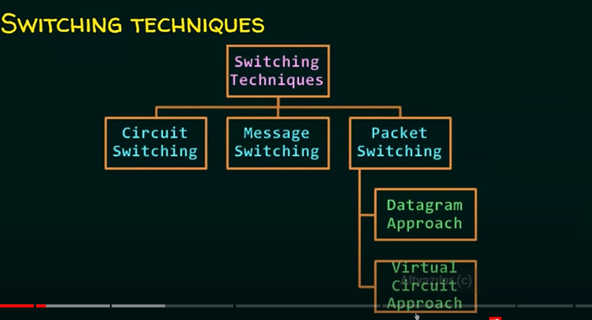

1. Circuit Switching
   1. A dedicated path is established between the sender and receiver
   2. Before data transfer, connection will be established first
   3. Example: Telephone network
   4. 3 phases in circuit switching
      1. Connection establishment
      2. Data transfer
      3. Connection disconnection
2. Message Switching
   1. Store and forward mechanism
   2. Message is transferred as a complete unit and forwarded using store and forward mechanism at the intermediary node.
   3. Suppose you have big data so you need to send them in smaller pieces. An intermediary node gets these pieces and compacts them and forwards the message to the receiver.
   4. Not suited for streaming media and real time applications.
3. Packet Switching
   1. The internet is a packet switched network
   2. Message şs broken into individual chunks called as packets
   3. Each packet is sent individually
   4. Each packet will have source and destination IP addresses with sequence numbers.
   5. Sequence numbers will help the receivers to
      1. Reorder the packets
      2. Detect missing packets
      3. Send acknowledgements
   6. 2 approaches:
      1. Datagram approach:
         1. Datagram packet switching is also known as connectionless switching
         2. Each independent entity is called as datagram
         3. Datagrams contain destination information and the intermediary devices use this information to forward datagrams to right destination
         4. In Datagram packet switching approach, the path is not fixed
         5. Intermediate nodes take the routing decisions to forward the packets.
      2. Virtual Circuit approach
         1. Also known as connection-oriented switching
         2. In the case of Virtual circuit switching a preplanned route is established before the messages are sent
         3. Call request and call accept packets are used to establish the connection between sender and receiver
         4. In this approach, the path is fixed for the duration of a logical connection.